Francs, marks, drachmas, pesetas, all gone… What happened?
The euro is the most widespread symbol of what the European Union (EU) is about unity and diversity. Unity- because it can be used in countries throughout Europe and has the same value in all of them; diversity- because the many designs of the national sides of Euro coins showcase the variety of Europe, its history, regions and cultures. (Paragraph 1)
The euro banknotes were inspired by the theme, “the ages and styles of Europe” and depict the architectural styles from seven periods of Europe’s cultural history. (Paragraph 2)
The windows and gateways on the front side symbolize the European spirit of openness and cooperation, while the bridges on the backside symbolize communication. (Paragraph 3)
Designs also include the name of the currency in both Latin (euro) and Greek alphabets, the official EU languages when the Euro notes and coins were first launched in 2002. (Paragraph 4)
There are eight euro coin denominations. Euro coins share a common front, but each country has designed their own special motif on the back. (Paragraph 5)

Hey, notice something different?
The coin’s edge is different for each denomination to aid recognition by the blind and partially sighted. Euro notes are different sizes for the same reason. (Paragraph 6)
Quality control of Euro coins adheres to stringent guild lines set by the European Central Bank (ECB), making it possible for a vending machine in Cadiz, Spain to accept a 20 cent coin minted in Stuttgart, Germany. (Paragraph 7)

Who uses the euro and why?
The euro is the currency of the 333 million people who live in 18 euro area countries. It is also used either formally as legal tender of for practical purposes, by other countries such as close neighbors and former colonies. It is therefore not surprising that the euro has rapidly become the second most important international currency after the dollar. (Paragraph 8)
Apart from making travelling easier within the EU, a single currency makes economic and political sense. The framework under which the euro is managed underpins it stability, contributes to low inflation and encourages good public finances. Using a common currency increases price transparency, eliminates currency exchange costs, and facilitates international trade giving the EU a more powerful voice in the world. (Paragraph 9)
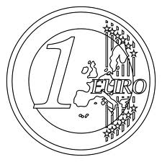

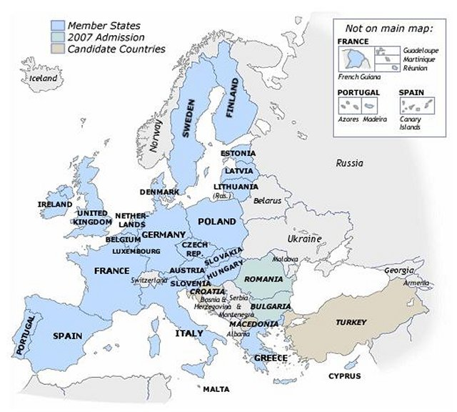
Countries Using the Euro (as of October 2013):

- Andorra
- Austria
- Belgium
- Cyprus
- Estonia
- Finland
- France
- Germany
- Greece
- Ireland
- Italy
- Kosovo
- Latvia
- Luxemborg
- Malta
- Monaco
- Montenegro
- Netherlands
- Portugal
- San Marino
- Slovakia
- Slovenia
- Spain
- Vatican City

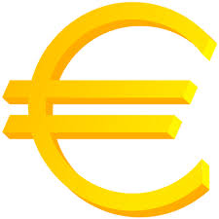
Note: There are two countries who have “opt-out” clauses in the EU treaty, exempting them from participation in using the Euro (Denmark and the United Kingdom). (Paragraph 10)

“The Euro” Guided Reading
Directions: Use the text to answer the following questions after you have read the article at least once. Be sure to write the paragraph in which you found each answer!
- What is the EU all about and why?

- The euro banknotes were inspired by the _______, “the __________________.”

- Do all countries in the EU use the euro? If not, which ones don’t? Why?

- How many countries use the Euro?

- Give at least 2 qualities of the euro bank notes.

- Give at least 2 qualities of the euro coins.

- The euro is the currency of _________ million people.

- The euro is the ________ most important international currency.
  - 1st
  - 2nd
  - 3rd
  - 4th

- The euro makes travel more difficult. TRUE / FALSE. Why?

