Unit 3 Exam Review
FRANCOPHONIE QUESTIONS:
1. Who is the current President of France?

2. Draw & color the French Flag

3. What is the National Motto of France?

4. TRUE/FALSE
French is spoken on all seven continents of the world. _________
There are no countries in South America in which French is spoken. ________
French is more commonly spoken in Western Africa than in Eastern Africa. ________
Francophone countries usually have different names in French than in English. ________
French is more commonly spoken in Western Africa than in Eastern Africa. ___________

5. Label the map of Europe with the following countries IN FRENCH!
Spain, Italy, Switzerland, Germany, Belgium, Luxembourg, France, England
English Channel & Mediterranean Sea

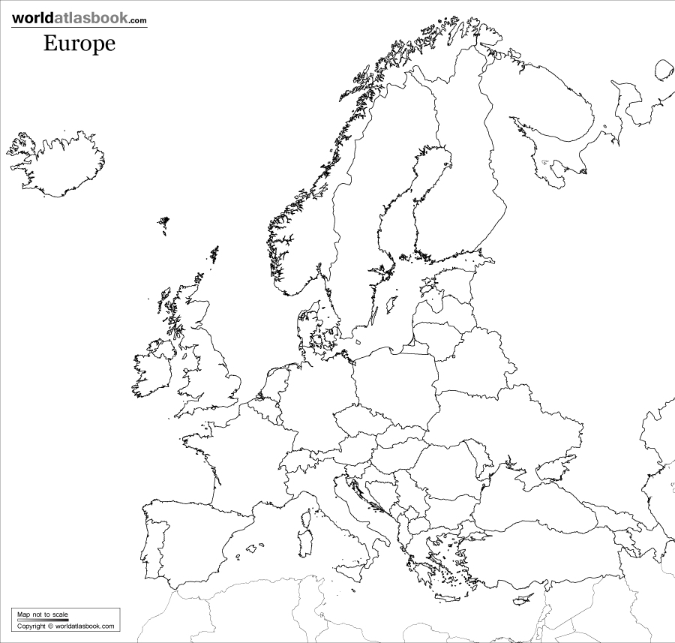

FRENCH REVOLUTION QUESTIONS:
1. How many “Estates” were there? Who was in each Estate? How was the system unfair?

2. How did the system of land ownership promote & maintain the “old order”?

3. Why could Louis XV be called an unsuccessful king (4)?

4. Why could Louis XIV be called a successful king (4)?

5. What is an absolute monarchy?

6. How was the American Revolution connected to the French revolution?

7. How was population a factor in the French revolution?

8. What were the consequences of the Necklace Scandal for Marie Antoinette and the monarchy?

9. How was Louis XVI executed?

10. Name the person described:
-One of the most influential figures during the Reign of Terror, this man sent thousands to the guillotine. His death ended the Reign of Terror. __________________
-Help write the Declaration of the Rights of Man and of the Citizen. Wrote a pamphlet in which he outline the desires and frustrations of the 3rd estate. ______________________
-Would eventually go on to become Emperor of France after the Revolution; during his reign he would restore aspects of the Old Regime he fought to destroy ____________________
-Brother to Marie Antoinette _______________________
-Leader during the Reing of Terror, best known for his radical journalism
-1st President of the Committee of Public Safety, voted for the death of Louis XVI _______________________
11. Give the dates for the following events:
Storming the Bastille
Execution of Louis XVI
Execution of Marie Antoinette

12. Explain the significance of the following events:
Storming of the Bastille

Tennis Court Oath

Death of Robespierre

ESSAY-Provide at least 2 examples to support your argument

1. Would you consider Marie Antoinette a good Queen? Why or Why not?

2. Do you think Louis XVI cared about the Revolution?

3. Compare/Contrast the Declaration of Independence to the Declaration of the Rights of Man. What were the purposes of these documents? How does each one define Liberty?

